Austrian participation in Clean Sky 2 highlighted at Aviation Forum

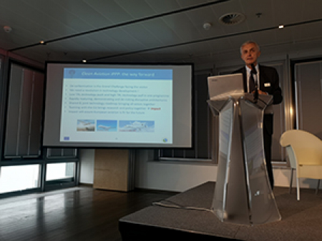

17 October 2019

Clean Sky’s Executive Director Axel Krein participated in the Aviation Forum Austria 2019 on 17 October in Vienna. The event, organised by BMVIT (the Austrian Ministry for Transport, Innovation and Technology), brought together more than 100 Austrian aviation stakeholders to discuss the strengths of Austria’s aviation industry and its perspective on a European level.   
    
In his keynote speech, Axel presented the high rate of participation of the Austrian aeronautics sector in the Clean Sky 2 programme, including projects such as [NO-ICE ROTOR](https://www.cleansky.eu/no-ice-rotor-a-greener-way-to-protect-aircraft-from-icing) which is contributing to the Leonardo Next Generation advanced tilt civil rotorcraft for faster, greener rotorcraft. He also looked at the future of European aviation research in Horizon Europe through a possible Clean Aviation Partnership programme.   
    
Read more about the event [here](https://open4aviation.at/de/veranstaltungen/2019/aviation-forum.php).